**Capstone Project**

**Hotel Booking Analysis**

Kshitija Deshmukh

**Overview :**

The given dataset is a comprehensive collection of hotel booking information that can be used for analysis and insights in various aspects of the hotel industry.

It contains a wide range of data related to hotel reservations, including booking details, guest information, booking source, room details, and reservation status.

It aims to explore and visualize trends, patterns, and key factors affecting hotel bookings and cancellations.

The dataset under analysis comprises comprehensive information related to hotel bookings, encompassing various aspects such as booking details, guest demographics, meal preferences, booking sources, room types, and reservation statuses. This diverse dataset is instrumental in gaining insights into the hospitality industry and visitor behavior.

1. Booking Analysis

This section delves into aspects related to the booking process itself. It examines trends over the years, including the number of bookings and cancellations, and identifies patterns like seasonality. Further, it investigates monthly booking patterns, analyzes the conversion rate, and explores differences between weekend and weekday stays.

2. Guest Analysis

Guest demographics are crucial for the hospitality industry. This analysis focuses on the distribution of adults, children, and babies in bookings. It also explores the impact of these demographics on cancellation rates. Additionally, it examines the Average Daily Rate (ADR) and its correlation with special requests.

3. Meal and Stay Analysis

Guests' meal preferences and stay durations are key factors in the hotel industry. This section delves into meal plans, their impact on ADR, and their distribution across booking channels. It also explores how meal plans relate to stay duration and parking requirements, identifying any preferences and patterns.

4. Booking Source and History Analysis

Understanding booking sources and guest history is crucial for optimizing marketing strategies. This section analyzes market segments, booking channels' effectiveness, and the proportion of repeated guests. It also delves into the impact of a guest's booking history on their current booking decisions.

5. Room Analysis

Guests' room preferences are central to their overall experience. This analysis focuses on the distribution of reserved and assigned room types, exploring whether guests receive the room type they initially reserved. It also investigates the impact of booking changes on cancellation rates and identifies room type preferences based on customer types.

6. Reservation Analysis

The reservation process and its outcomes are integral to the hotel business. This section provides an overview of reservation statuses over time, including cancellations, check-outs, and no-shows. It also examines trends in reservation status dates, explores how reservation statuses vary across different customer types, and investigates the relationship between reservation status and ADR.

In summary, this dataset offers a wealth of information that can be harnessed for a broad spectrum of analyses in the hospitality industry. The categorization into Booking Analysis, Guest Analysis, Meal and Stay Analysis, Booking Source and History Analysis, Room Analysis, and Reservation Analysis allows for a comprehensive exploration of this rich dataset to make data-driven decisions and enhance the guest experience.

**Problem Statement :**

Analyze booking patterns, guest preferences, and factors influencing cancellations. Use SQL and Excel to identify trends in booking sources and revenue. Develop a Power BI dashboard for tracking booking trends and optimizing hotel operations.

Objective:

The overarching objective is to gain a holistic understanding of the hotel's operations, guest behavior, and revenue drivers.

Analysis Scope:

The analysis spans various facets of the hospitality industry, including booking trends, guest demographics, meal and stay preferences, booking sources and history, room allocation, and reservation statuses.

Goal:

The ultimate goal is to make data-driven decisions to optimize revenue, enhance guest satisfaction, and improve operational efficiency.

### **Significance :**

### Valuable Insights: The dataset provides valuable insights into the hotel industry, enabling data-driven decision-making. It helps uncover hidden patterns, guest preferences, and booking trends that can inform strategic choices.

### Improvement Focus: By analyzing this dataset, hotels can identify areas for improvement in their operations. This includes enhancing guest experiences, optimizing marketing strategies, and streamlining booking processes.

### Evaluation of Effectiveness: Hotel chains can evaluate the effectiveness of their marketing efforts, booking channels, and room allocation strategies. It allows them to assess the success of past initiatives and make adjustments as needed.

### Trend Identification: The dataset allows for the identification of trends, both short-term and long-term. This can be vital for adapting to changing market conditions, optimizing pricing strategies, and capitalizing on peak booking periods.

### Comprehensive Understanding: The dataset offers a comprehensive understanding of the entire guest journey, from booking to check-out. This holistic view enables hotels to create tailored experiences, improve guest satisfaction, and maximize revenue.

### In summary, this dataset is significant because it empowers hotel chains to gain valuable insights, focus on areas needing improvement, evaluate the effectiveness of strategies, identify trends, and achieve a comprehensive understanding of their operations, ultimately leading to better decision-making and enhanced performance in the hospitality industry.

### **Dataset Description :**

This dataset contains information on hotel bookings, guest details, meal preferences, booking source, room details, and reservation status.

### **Table Explanations :**

#### Room_Details

The Room_Details table provides information related to room reservations and changes made to them. It is associated with the Booking_Details table via the booking identifier. This table includes details about the type of room initially reserved, the type of room eventually assigned, and the number of changes made to the booking. It offers insights into room allocation dynamics and booking modifications.

#### Reservation_Status*

The Reservation_Status table records the status of reservations over time. It is connected to the Booking_Details table through the booking identifier. This table captures the reservation's last status (e.g., Canceled, Check-Out) and the date on which this status was recorded. It is valuable for tracking the progression of reservations and understanding their final outcomes.

#### Booking_Details

The Booking_Details table contains essential details related to hotel reservations. It includes a unique booking identifier and information about the type of hotel (Resort Hotel or City Hotel). Additionally, it records the booking's cancellation status (0 for not canceled, 1 for canceled), lead time (number of days between booking and arrival), year, month, week number, and day of the month of arrival. The table also captures the number of weekend and weekday nights stayed.

#### Guest_Info

The Guest_Info table provides insights into the guests associated with each booking. It is linked to the Booking_Details table via the booking identifier. This table records the number of adults, children, and babies accompanying the booking, offering an understanding of the composition of guests for each reservation.

#### Meal_And_Stay_Details

The Meal_And_Stay_Details table complements the booking information by specifying meal-related and stay-related attributes. It connects to the Booking_Details table via the booking identifier. This table includes the type of meal booked (e.g., Bed & Breakfast, Half Board), the Average Daily Rate (ADR) for the stay, the number of required car parking spaces, and the total count of special requests made by the guest.

#### Booking_Source_and_History

The Booking_Source_and_History table is crucial for understanding the source of bookings and the historical behavior of guests. It is connected to the Booking_Details table via the booking identifier. This table encompasses information such as the market segment (e.g., Online Travel Agents, Direct Booking), distribution channel (e.g., Online Travel Agents, Direct Booking), and whether the guest is a repeated visitor (0 for not repeated, 1 for repeated). Additionally, it records the number of previous booking cancellations, previous bookings that were not canceled, the deposit type (e.g., No Deposit, Non-Refund), the booking agent's ID, the company's ID, the number of days a booking spent on the waiting list, and the customer type (e.g., Transient, Group).

**Data Dictionary:**

**ER Diagram :**

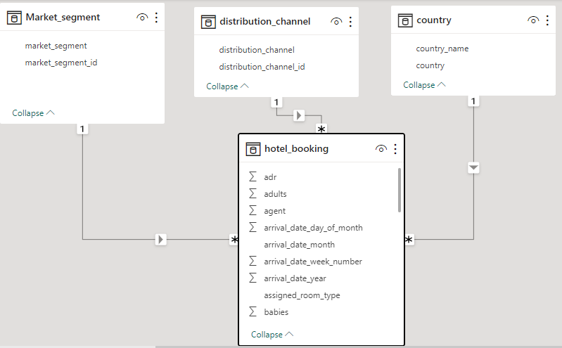

I downloaded the data from GitHub.There are 9 tables in which 33 unique columns are present. Booking_details, Booking_source_&_history, Guest_info, Meal_&_stay_details, Reservation_details, Room_details these tables have common column called booking_id , with the help of this column 6 tables join with each other to get one fact table. This fact table join with Country table by country column, Distribution_channel table by distribution_channel_id column, Market_segment by market_segment_id.

I check data for finding out nulls or blanks present in data. I fill blanks in categorical column by most repeated value in that column.

For EDA I used Excel, SQL, Power BI. For some questions of EDA cancellation rate required so I used Power BI because I am easily create new measure using dax function in Power BI. For some Power BI questions, I used dax function to create new measures.

**Problems :**

**EDA Questions :**

1.Understand the distribution of arrival dates, including the most common arrival days and summary statistics for lead times.

2.Identify peak booking months and analyze reasons for spikes in bookings, including holidays or events.

3.Calculate the average length of stays for different hotel types and explore variations by meal plans.

4.Analyze how booking patterns have evolved over the years, including yearoveryear changes in bookings and cancellations.

5.Understand the distribution of the number of adults, children, and babies and identify any outliers.

6.Calculate summary statistics for ADR and explore differences between Resort Hotel and City Hotel Bookings.

7.Analyze the distribution of required car parking spaces for each hotel type and determine if one type attracts more guests with cars.

8.Compare the total number of special requests made by different customer types (e.g., Transient, Group) and identify which customer type makes more requests.

9.Understand the distribution of meal plans (e.g., BB, HB, FB, SC) and identify any patterns or preferences.

10.Analyze Average Daily Rates (ADR) by meal plan type to identify variations in pricing.

11.Investigate the distribution of required car parking spaces and special requests by hotel type and meal plan. 12 .Compare the distribution of meal plans among different customer types (e.g., Transient, Group) to identify preferences.

12.Understand the distribution of bookings across different market segments and calculate summary statistics for lead times within each segment.

13.Analyze the distribution of bookings through different booking channels (e.g., online travel agents, direct bookings) and calculate the percentage of bookings through each channel.

14.Calculate the proportion of repeated guests and investigate their booking behavior. Identify any patterns or differences in preferences compared to first time guests.

15.Explore the impact of a guest's booking history on their likelihood of canceling a current booking. Calculate cancellation rates based on previous cancellations and non canceled bookings.

16.Understand the distribution of reserved and assigned room types. Calculate summary statistics for the consistency between reserved and assigned room types. 17.Analyze the impact of booking changes on cancellation rates. Calculate cancellation rates for bookings with different numbers of changes.

18.Explore how room type preferences vary across different customer types (e.g., Transient, Group). Identify if certain customer types have specific room preferences.

19.Examine whether guests who make multiple bookings have consistent room type preferences or if their preferences change over time.

20.Understand the distribution of reservation statuses and calculate summary statistics for reservation status dates..

21.Analyze trends in reservation status dates, including the most common checkout dates and any seasonality patterns.

22.Explore how reservation statuses vary across different customer types (e.g., Transient, Group) using Excel or SQL. Calculate cancellation rates by customer type.

23.Investigate whether there are differences in Average Daily Rates (ADR) based on reservation status (e.g., canceled vs. checkedout).

**Power Bi questions :**

1.Visualize booking trends over the years, including the number of bookings, cancellations, and average lead time. Identify seasonality patterns.

2. Analyze monthly booking patterns to identify peak months and optimize marketing strategies.

3. Compare stays in weekend nights and weekday nights to determine preferences and variations by hotel type.

4. Calculate and visualize the booking conversion rate (canceled bookings to total bookings) over time.

5. Visualize the distribution of adults, children, and babies in bookings. Explore the impact of children and babies on cancellation rates.

6. Analyze the distribution of Average Daily Rates (ADR) and identify correlations with the number of special requests made by guests.

7. Visualize the relationship between the number of required car parking spaces and booking types (Resort Hotel vs. City Hotel).

8. Use Power BI to explore how the total number of special requests made by guests varies by hotel type and customer type (e.g., Transient, Group).

9. Explore meal plans and their impact on Average Daily Rates (ADR). Analyze meal plan preferences and their association with booking channels.

10. Analyze how meal plans correlate with stay duration and investigate any differences in stay lengths based on meal plans.

11. Correlate parking requirements and special requests with different meal plans. Determine if certain meal plans result in more requests or parking needs.

12. Explore how meal plans are distributed across various booking channels. Analyze if certain channels are associated with specific meal plans.

13. Visualize booking distribution across different market segments and analyze cancellation rates within each segment.

14. Compare the effectiveness of booking distribution channels in generating confirmed bookings. Identify the most commonly used channels by guests.

15. Visualize the percentage of repeated guests for each hotel type (Resort Hotel vs. City Hotel) over time. Explore factors influencing guest retention.

16. Analyze the impact of a guest's booking history (previous cancellations and noncanceled bookings) on their likelihood of canceling a current booking.

17. Visualize the distribution of reserved and assigned room types. Analyze whether guests tend to receive the room type they initially reserved.

18. Investigate the relationship between the number of booking changes made by guests and their likelihood of canceling a booking.

19. Analyze room type preferences based on customer types (e.g., Transient, Group) and identify any patterns in room type selection.

20. Analyze whether guests who make multiple bookings tend to consistently request the same room type or if their preferences change over time.

21. Provide an overview of reservation statuses over time, including the percentage of canceled, checked-out, and no show bookings.

22. Analyze trends in reservation status dates, such as the busiest checkout dates or patterns in cancellations by month.

23. Visualize how reservation statuses vary across different customer types (e.g., Transient, Group) and identify if certain customer types are more likely to result in cancellations or noshow.

24. Explore the relationship between reservation statuses and Average Daily Rates (ADR) to determine if there are differences in ADR based on booking outcomes.

**Solutions :**

**1.Booking Analysis :**

**EDA :**

1.Understand the distribution of arrival dates, including the most common arrival days and summary statistics for lead times.

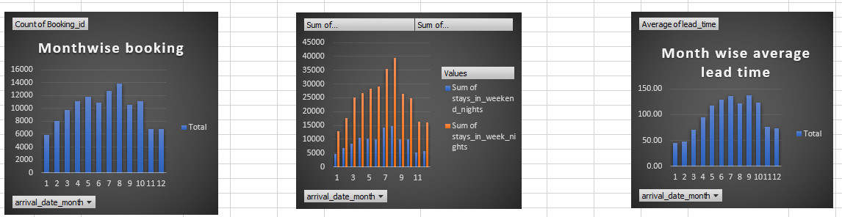

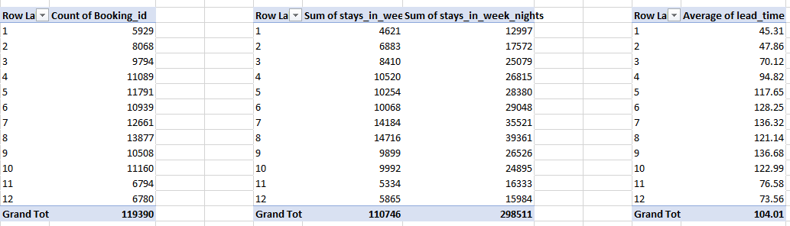

From barchart, we conclude that guest gives preference to weekdays nights. And in month of august most of guest arrived at hotel. And in august most of guest gives preference to weekdays only.   
 Average lead time for july and september is maximum and for month of january it is minimum.

2. Analyze monthly booking patterns to identify peak months and optimize marketing strategies.

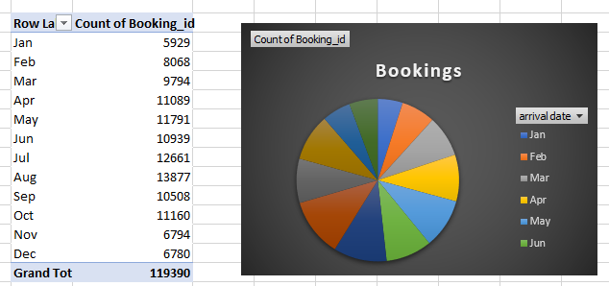

. We find that for August maximum i.e. 13877 bookings are done. I am not sure about perfect reason behind this maximum bookings are done in august as there is no given any event, festival or hotel location. But here I am trying to guess the reason it's may be wrong. One possibility of these maximum bookings for august is that may be in august most holidays or events or festivals are comes. So students, working people get holiday and may be with friends or family they went for picnic.

3.Calculate the average length of stays for different hotel

types and explore variations by meal plans.

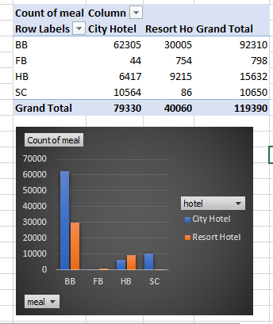

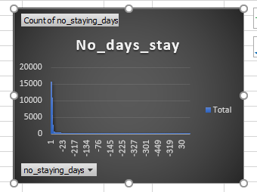

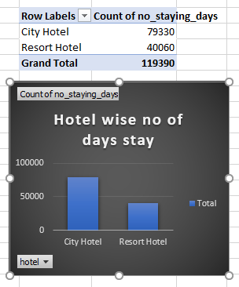We see that BB type meal is most popular. In city hotel meal order maximum compare to resort hotel. In august, both hotels have max order of meal than any other month. In city hotel & resort hotel, FB meal & SC meal has minimum order respectively.

Mostly guest gives preference to city hotel for stay. Mostly guest book room for 1 night but average of stay is about 9 days. Mostly guest gives preference to august month.

4.Analyze how booking patterns have evolved over the years, including year over year changes in bookings and cancellations.

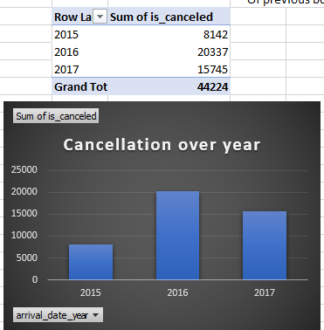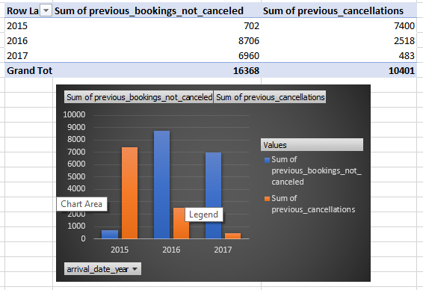

In 2016 maximum no. of bookings canceled. For previous booking cancellation 2015 has maximum no. of cancellations and for 2016 maximum no. Of previous bookings not canceled.

**Power BI**

1.Visualize booking trends over the years, including the number of bookings, cancellations, and average lead time. Identify seasonality patterns.

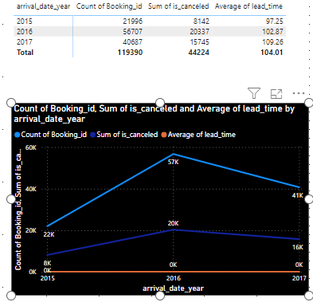

In 2016 Maximum no. of bookings are done.

3. Compare stays in weekend nights and weekday nights to determine preferences and variations by hotel type.

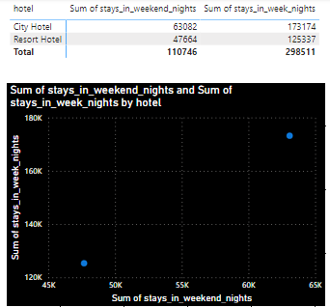

Guest gives preference to weekday nights and city hotel.

4. Calculate and visualize the booking conversion (canceled bookings to total bookings) over time.

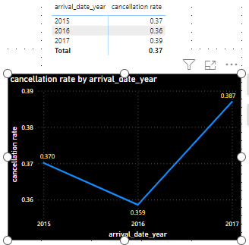

In 2017 cancellation rate is maimum as compired to cancellation rate of 2015 and 2016

15. Visualize the percentage of repeated guests for each hotel type (Resort Hotel vs. City Hotel) over time. Explore factors influencing guest retention.

For 2017, Resort hotel has maximum rate of repeated guest. For city hotel maximum repeated guest calculated for 2015.

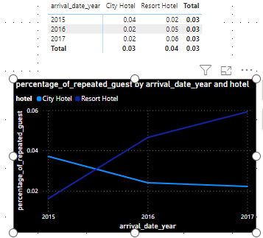

**Booking_source_&_history_analysis**

**EDA**

12.Understand the distribution of bookings across different market segments and calculate summary statistics for lead times within each segment.

From combo chart for market segment wise count of bookings and average lead time, we can see that , for market segment Online TA has maximum no. of bookings are done and there average lead time is 83 days. For undefined market segment average lead time is minimum i.e. one and half day & second least average time is 4.44 days for Aviation market segment.

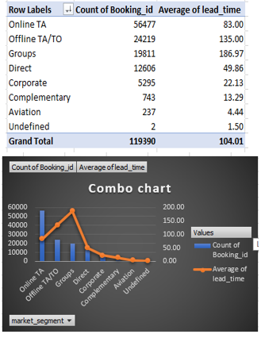

13.Analyze the distribution of bookings through different booking channels (e.g., online travel agents, direct bookings) and calculate the percentage of bookings through each channel.

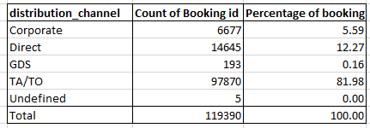

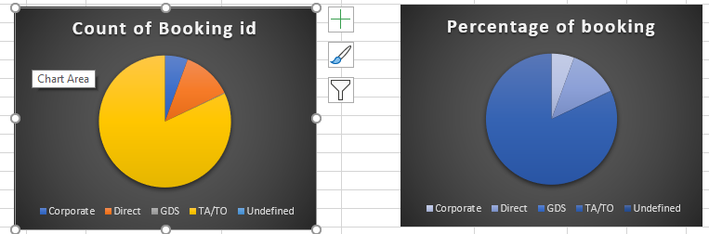

For distribution channel TA/TO has maximum percentage of booking. 1st preference is TA/TO channel and second to preference Direct distribution channel.

14.Calculate the proportion of repeated guests and investigate their booking behavior. Identify any patterns or differences in preferences compared to first time guests.

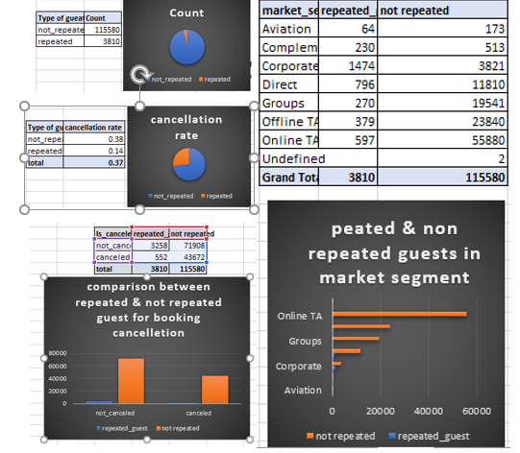

Repeated guests are very less i.e. 3810. But cancellation rate is high as compared to count of repeated guest and cancellation rate of non repeated guest. From corporate distribution channel and market segment repeated guests are maximum.

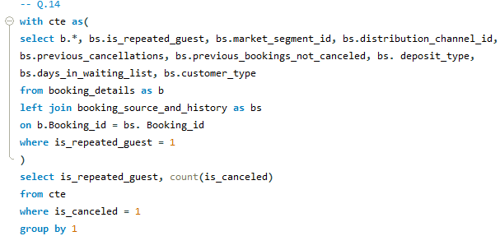

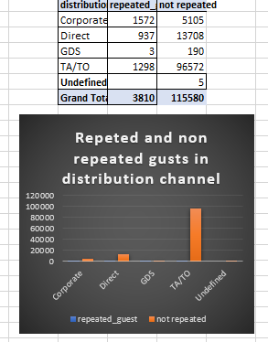

15.Explore the impact of a guest's booking history on their likelihood of canceling a current booking. Calculate cancellation rates based on previous cancellations and noncanceled bookings.

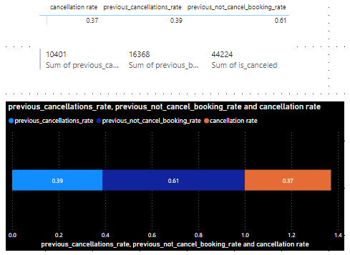

Previous cancellation rate is greater than current cancellation booking rate. By calculation current not cancellation rate 0.63 which is greater than previous not cancellation rate.

**Power BI**

2. Analyze monthly booking patterns to identify peak months and optimize marketing strategies.

Maximum bookings are done for august.

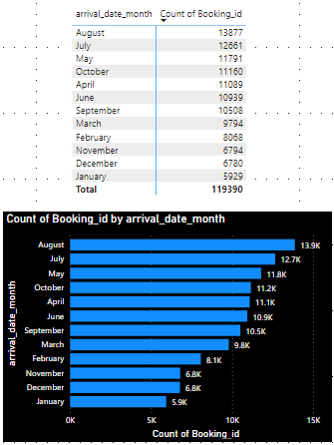

13. Visualize booking distribution across different market segments and analyze cancellation rates within each segment.

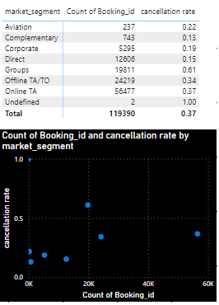

Maximum bookings done trough online TA market segment.

Cancellation rate of Group market segment is maximum than any other market segment.

14. Compare the effectiveness of booking distribution channels in generating confirmed bookings. Identify the most commonly used channels by guests.

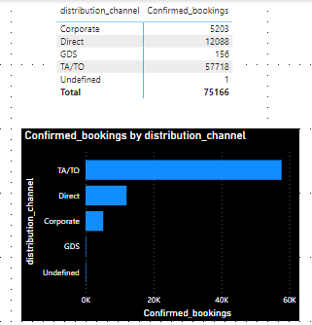

TA/TO distribution channel most commonly used channel as confirmed bookings through this channel is maximum.

16. Analyze the impact of a guest's booking history (previous cancellations and non canceled bookings) on their likelihood of canceling a current booking.

%Previous cancellation for Group customer is less and %previous not cancelled booking is maximum. Previously maximum Group customers not cancelled bookings and cancellation rate is very less i.e. for present time also Group customer cancelled bookings are less.

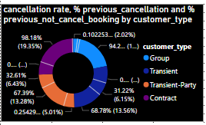

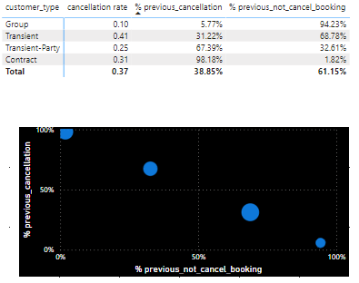

**Meal_&_stay_analysis**

**EDA**

6.Calculate summary statistics for ADR and explore differences between Resort Hotel and City Hotel bookings.

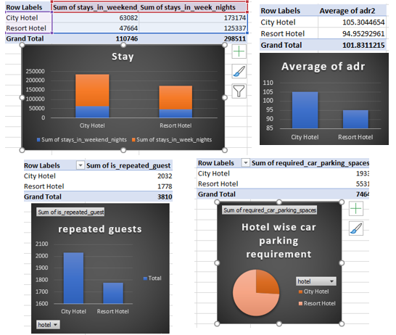

Maximum bookings are done in city hotel. Also avg adr, sum of adr of city hotel is greater than resort hotel. Guest repeatedly comes in city hotel campaired to resort hotel.

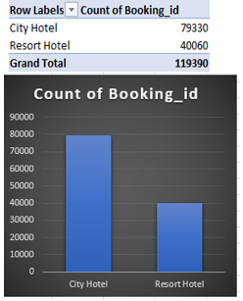

. Maximum bookings are done in city hotel. Also avg adr, sum of adr of city hotel is greater than resort hotel. Guest repeatedly comes in city hotel campaired to resort hotel.

7.Analyze the distribution of required car parking spaces for each hotel type and determine if one type attracts more guests with cars.

Resort hotel required more car parkings than city hotel

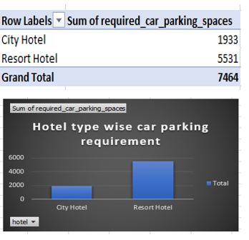

8.Compare the total number of special requests made by different customer types (e.g., Transient, Group) and identify which customer type makes more requests.

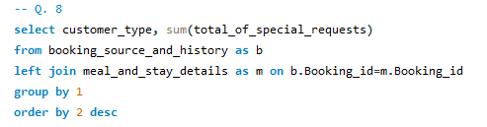

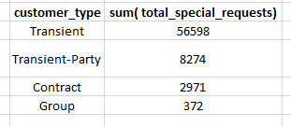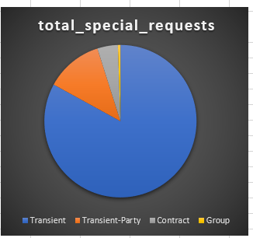

Transient Customers made more special requests.

9.Understand the distribution of meal plans (e.g., BB, HB, FB, SC) and identify any patterns or preferences.

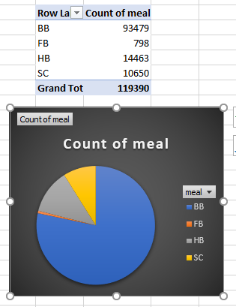

BB type of meal is popular meal as its count is maximum & it has a maximum sum of average daily rate. In month of august maximum no. of meal order place & in that orders BB type meal order is maximum.

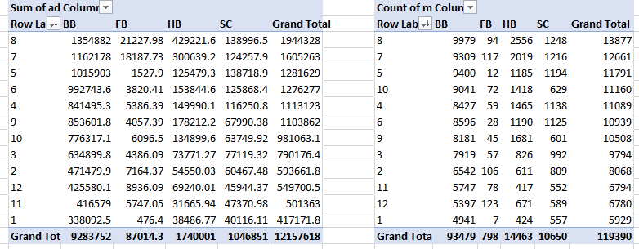

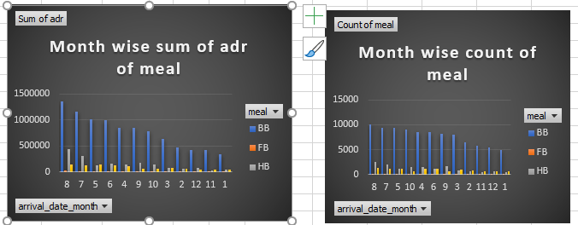

BB type of is most popular meal as it has maximum no. of count , also it has maximum sum of average daily rate. In august, maximum no. of meal orders is place & in that orders BB type meal orders are maximum.

10.Analyze Average Daily Rates (ADR) by meal plan type to identify variations in pricing.

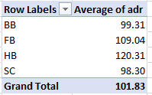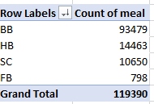

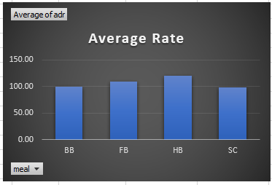

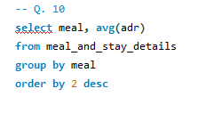

Count of BB meals is maximum. It's average rate is about 99.31 which is minimum than any other meal rate. So, it is best, convenient meal plan for everyone.

11.Investigate the distribution of required car parking spaces and special requests by hotel type and meal plan. 12 .Compare the distribution of meal plans among different customer types (e.g., Transient, Group) to identify preferences.

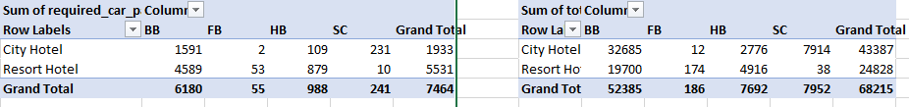

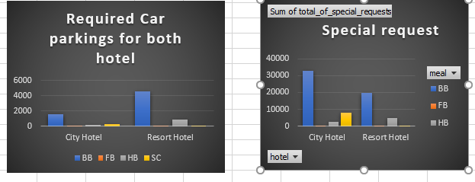

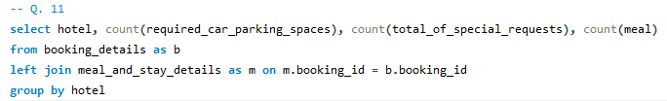

we conclude that resort hotel guests required maximum no. of parkings and most of them order BB type of meal. From 2nd chart we get that city hotel's guests who order BB type meal they have maximum no. of special requests. So combinely we can say that city hotel guests who prefered BB type meal they have maximum special requests also they want maximum no. of car parkings.

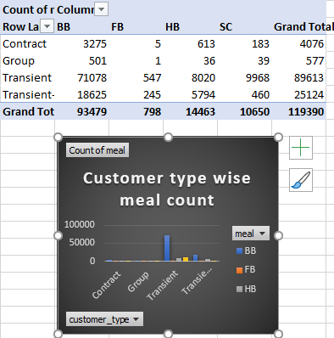

All 4 types of customerce like contract, group, transient, transient-party give preference to BB type meal. But transient customer order maximum no. of BB meal.

**Power BI**

6. Analyze the distribution of Average Daily Rates (ADR) and identify correlations with the number of special requests made by guests.

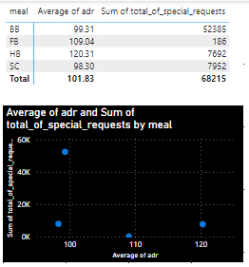

Those guests ordering BB meal they have more special requests than any other guests. Average of adr is not so high not so less. It is a best amount consuming for food for anyone.

7. Visualize the relationship between the number of required car parking spaces and booking types (Resort Hotel vs. City Hotel).

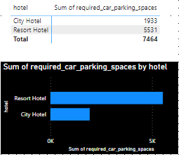

Resort hotel require maximum number of car parkings.

8. Use Power BI to explore how the total number of special requests made by guests varies by hotel type and customer type (e.g., Transient, Group).

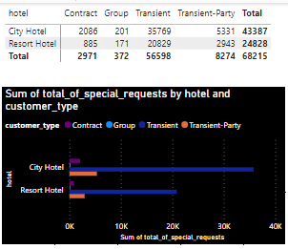

City hotel has maximum guests but maximum guests are of transient customer type

9. Explore meal plans and their impact on Average Daily Rates (ADR). Analyze meal plan preferences and their association with booking channels.

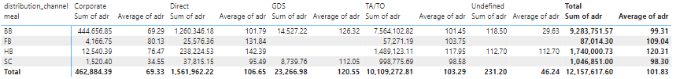

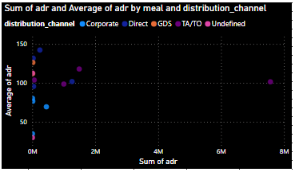

TA/TO distribution channel guests who order BB meal from them hotel gets maximum cost for food.

10. Analyze how meal plans correlate with stay duration and investigate any differences in stay lengths based on meal plans.



Data is not there in table, when I am trying to get data by available column it showing error.

11. Correlate parking requirements and special requests with different meal plans. Determine if certain meal plans result in more requests or parking needs.

Guests who are taking BB type meal they required maximum number of parkings and they have have maximum number of special requests.

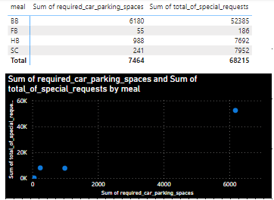

12. Explore how meal plans are distributed across various booking channels. Analyze if certain channels are associated with specific meal plans.

Mostly all channels give preference to BB meal. GDS channel give preference to only BB or SC meal. Undefined channel give preference to only BB or HB meal.

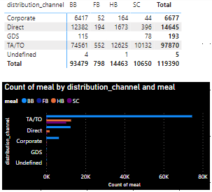

**Guest_analysis**

**EDA**

5.Understand the distribution of the number of adults, children, and babies and identify any outliers.

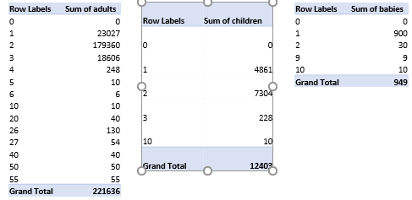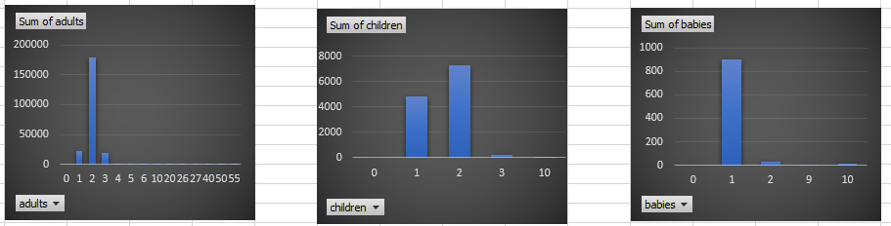

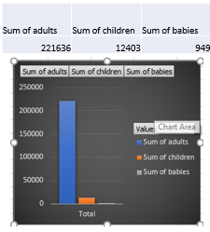

Count of adults is maximum than children and babies.

**Power BI**

5. Visualize the distribution of adults, children, and babies in bookings. Explore the impact of children and babies on cancellation rates.

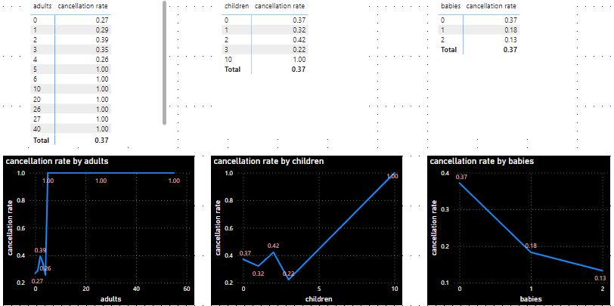

Count of adults is maximum than babies or children. Impact of children on the cancellation rate is more.

**Room_analysis**

**EDA**

16.Understand the distribution of reserved and assigned room types. Calculate summary statistics for the consistency between reserved and assigned room types.

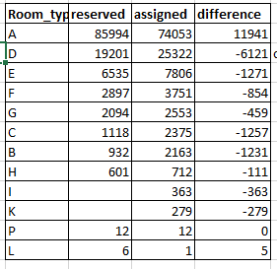

Maximum guest reserved A type room and also maximum no. of guest assigned the A type room. So, we can say that A type room was in high demand room type ( may be it's nice and it's cost is affordable ) and they are maximum in no. But also 11941 guest doesn't get there reserved room A. And no one reserved I, K room. 12 guest reserved P room and same no. of P rooms assigned to gust. 6 guest reserved L room but only 1 guest get the L room.

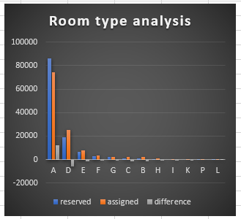

17.Analyze the impact of booking changes on cancellation rates. Calculate cancellation rates for bookings with different numbers of changes.

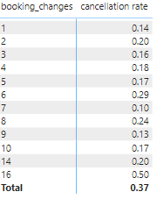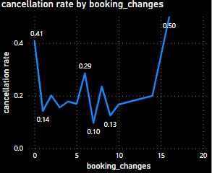

As booking changes increases Cancellation rate also increases. That is booking_changes directly proportional to cancellation_rate

18.Explore how room type preferences vary across different customer types (e.g., Transient, Group). Identify if certain customer types have specific room preferences.

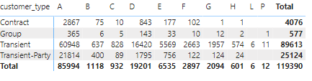

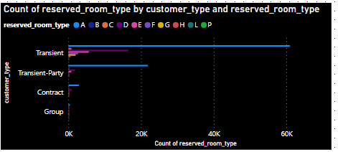

Contract, group, transient and transient-party customers mostly preferred the A type room. Contract and transient party not give any preference to L and P rooms. Only 1 preference given by one group customer to P room. And Transient customers reserved 6 L rooms and 11 P rooms. we see that B, C, H, L, P rooms are least preferable rooms.

19.Examine whether guests who make multiple bookings have consistent room type preferences or if their preferences change over time.

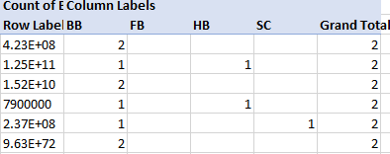

only through 6 booking id more than one booking i.e. 2 bookings are done. All of they give preference for BB meal for atleast 1 people and for other one they give preference to HB or Sc meal otherwise they give preference to BB meal for both bookings.

**Power BI**

17. Visualize the distribution of reserved and assigned room types. Analyze whether guests tend to receive the room type they initially reserved.

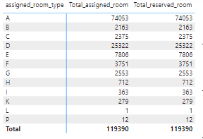

Power BI not showing proper values for reserverd room

18. Investigate the relationship between the number of booking changes made by guests and their likelihood of canceling a booking.

Transient customers have maximum count of booking cancellation as well as booking changes.

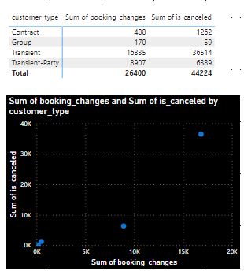

19. Analyze room type preferences based on customer types (e.g., Transient, Group) and identify any patterns in room type selection.

Maximum customers of each type give preference to A room. Only some customer of gives preference to L room. Some customers of group and transient gives preference to P room.

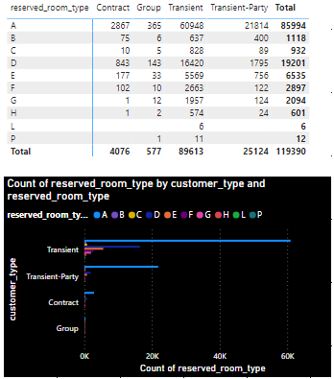

20. Analyze whether guests who make multiple bookings tend to consistently request the same room type or if their preferences change over time.

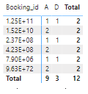

Three guests from multiple bookings i.e. 2 bookings they give preference to A room but other three gives preference to both A & D room.

**Reservation_analysis**

**EDA**

20.Understand the distribution of reservation statuses and calculate summary statistics for reservation status dates..

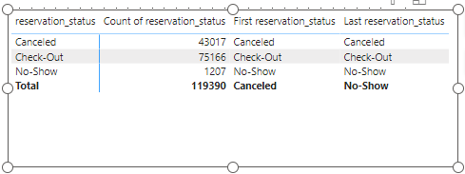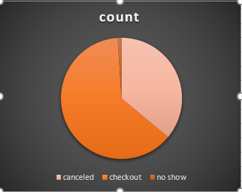

Most off the guest status is checkout.

21.Analyze trends in reservation status dates, including the most common checkout dates and any seasonality patterns.

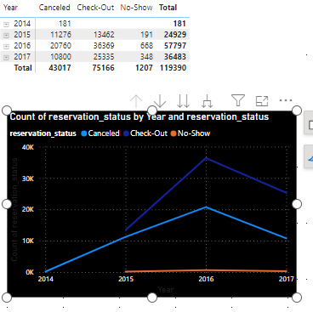

In 2016 maximum cancellation done and in 2014 all 181 bookings was canceled. Maximum checkout done in 2016 and least checkout in 2015.

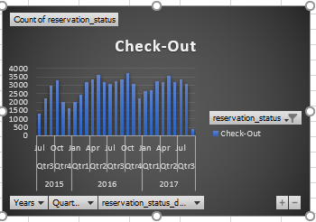 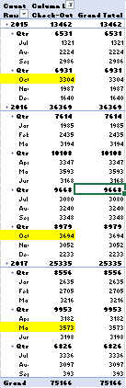

In oct 2016 maximum check out done then in may 2017 3575 checkout done and in oct 2015 minimum 3304 checkout done

22.Explore how reservation statuses vary across different customer types (e.g., Transient, Group) using Excel or SQL. Calculate cancellation rates by customer type.

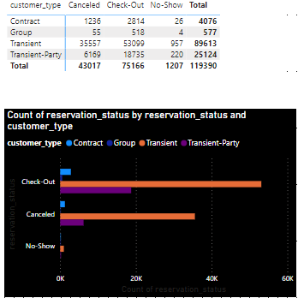

Cancellation rate of transient customer is high. For transient Check-out count is maximum. Count of no show status is negligible for contract, group and transient-party customer type.

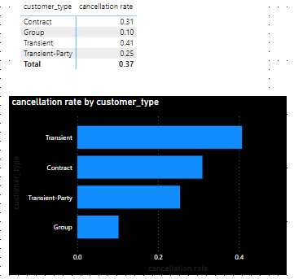

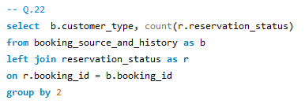

23.Investigate whether there are differences in Average Daily Rates (ADR) based on reservation status (e.g., canceled vs. checked out).

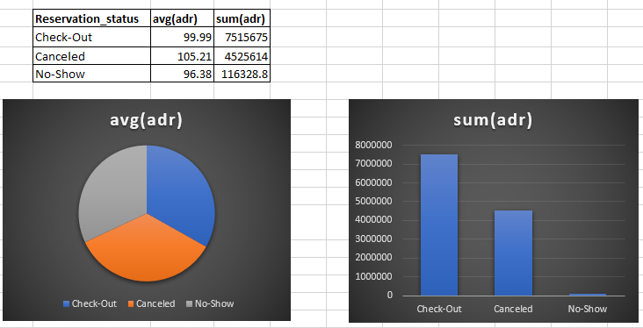

Yes, average daily rate changes as per reservation status. For check-out status sum of adr is maximum and for canceled status average of adr is maximum.

**Power BI**

**Power BI**

21. Provide an overview of reservation statuses over time, including the percentage of canceled, checked-out, and no show bookings.

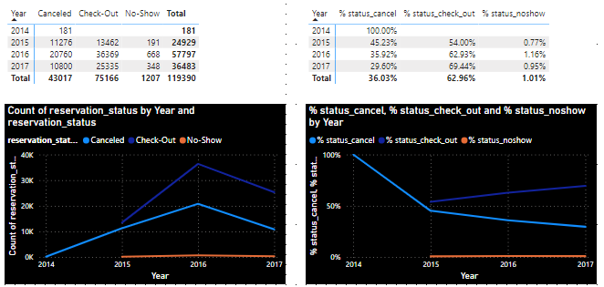

In all three years percentage of checked out guests is more than percentage of canceled guests. But in 2017 percentage of check out status is maximum but count of check out status maximum for 2016.

22. Analyze trends in reservation status dates, such as the busiest checkout dates or patterns in cancellations by month.

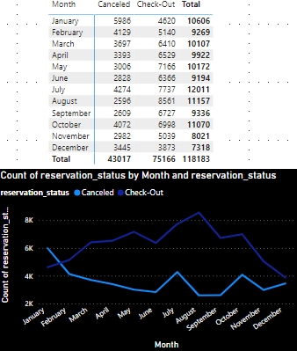

Maximum number of cancel status shows for January and August has maximum number of checked out status.

23. Visualize how reservation statuses vary across different customer types (e.g., Transient, Group) and identify if certain customer types are more likely to result in cancellations or noshow.

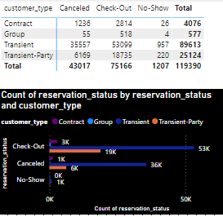

Transient customers has maximum number of cancellation as well as no show reservation status.

24. Explore the relationship between reservation statuses and Average Daily Rates (ADR) to determine if there are differences in ADR based on booking outcomes.

Most of cost (sum of adr) obtained from checked out guests.

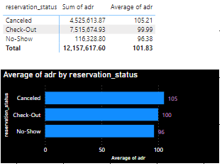

**Conclusion :**

In this hotel booking analysis project, we set out to examine and gain insights from a dataset related to hotel bookings. Through a series of data cleaning, exploration, and statistical analysis techniques, we have arrived at several important conclusions:

1. **Booking analysis:** Our analysis revealed that there are clear seasonal patterns in hotel bookings, with peak booking periods occurring during specific months or seasons. Guests gives preference to city hotel, august month and weekdays.
2. **Booking sources and history analysis :** We found that a significant portion of bookings come from online TA market segment and TA/TO districution channel as compared to any other market or distribution channel. This highlights the importance of an effective online presence and partnerships with OTAs.
3. Meal analysis : We find out that BB type meal is most preferable meal.
4. Room analysis : Most of guests preffered A type room and some rooms have very less or no bookings.
5. Guest analysis : Most of gusts are adult. Cildren and babies count are very less.
6. Reservation status analysis : Count of check out sttaus is maximum but cancellation status is not so minimum. In 2016 most of bookings cancelled.
7. The analysis of cancellation rates showed that a substantial number of bookings are canceled, particularly for certain types of rooms or booking sources.

**Suggestion :**

1. Understanding the reasons behind these cancellations can help in revenue optimization.
2. Analyze the reasons behind booking cancellations and develop strategies to reduce cancellation rates. This could include flexible cancellation policies or incentives for non-cancellable bookings. Use predictive models to forecast potential cancellations and allocate inventory accordingly.
3. Remain adaptable to changing travel restrictions and health guidelines, and have contingency plans in place for various scenarios.
4. Continue to analyze booking data regularly to detect emerging trends and adjust strategies accordingly.
5. Monitor the effectiveness of implemented recommendations and iterate on them as needed.
6. Continuously monitor competitor pricing, offerings, and customer reviews to stay competitive in the market.
7. Benchmark your hotel's performance against competitors and identify areas for improvement.
8. Implement dynamic pricing strategies that consider factors like seasonality, demand patterns, and booking lead times to maximize revenue.
9. Consider offering personalized pricing or packages to different customer segments to increase conversion rates.